KING DAVID HIGH SCHOOL LINKSFIELD



MATHEMATICS

GRADE 12 PRELIM EXAMINATION

AUGUST 2009

Total: 150 marks

Reading Time: 10 minutes Writing Time: 3 hours

This paper contains 7 pages (including this cover), a data sheet and an answer page.
Check that your paper is complete.

Please read the following instructions carefully:

1. Answer all questions on foolscap paper. Answer Question 5 on the
answer sheet provided.

2. Pay careful attention to time management and mark allocation.

3. Write legibly and not in pencil.

4. Calculators may be used unless otherwise instructed.

5. All necessary calculations must be clearly shown. You will NOT receive
full credit if you write down only the answers and show no working out.

Q1  [6] | Q2  [7] | Q3  [14] | Q4  [16] | Q5  [15] | Q6  TOTAL  _____  150  [15]
Q7  [21] | Q8  [12] | Q9  [8] | Q10  [16] | Q11  [4] | Q12  [4] | Q13  [12]
NAME:

QUESTION 1

Evaluate

a) $\frac{4^{n+1}\text{.}8^{2n}}{{\text{16}}^{2n−1}}$ (3)

b) 9 – 3 + 1 – . . . (3)
[6]

QUESTION 2

Solve for x

a) $\sqrt{3x−2}=x−2$ (4)

b) log₂ 3 – log₂ x = log₂ 9 (3)
[7]

QUESTION 3

The sketch represents the graphs of f and g which are not drawn to scale.
f(x) = $\frac{k}{x}$; x > 0 and passes through A(3 ; 2)
g(x) = - log_{p}x and passes through B(2 ; −1)

f

A(3 ; 2)
•

B(2 ; −1)
•
g

a) Find the values of p and k (3)

b) Determine g⁻¹ in the form g⁻¹(x) = ……… (2)

c) Sketch g⁻¹(x) (2)

d) What is the range of g⁻¹(x) (1)

e) Calculate $f^{'}(2)$ (3)

f) (i) Write down the equation of the graph found by moving f
three units to the left and 2 units down. (2)

(ii) What is the y intercept of this new graph? (1)
[14]

QUESTION 4

- The parabola y = f(x) cuts the x – axis at (1 ; 0) and (3 ; 0) and cuts the
y – axis at (0 ; 3).

- Show that the equation is f(x) = (x – 2)² – 1. (5)
(ii) Write down the equation of y = f(x + 2) (1)
(iii) Write down the equation of y = f(x) + 2 (1)
(iv) Write down the value of k if y = f(x) + k passes through
(0 ; 0) (2)

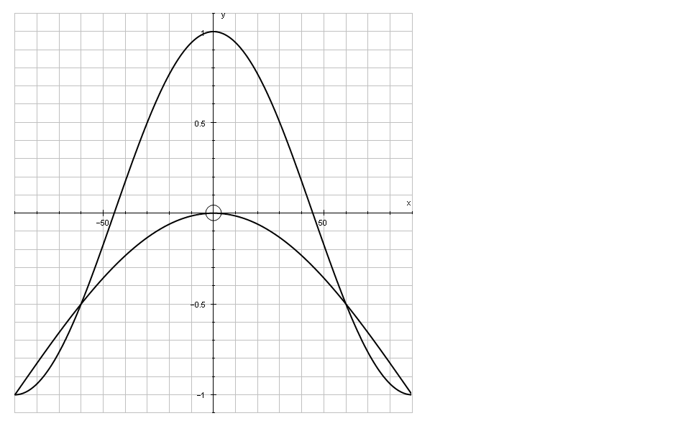
b)

The graphs of f(x) = cos x + p and g(x) = cos qx are illustrated above.
x$∈[−{\text{90}}^{o};{\text{90}}^{0}]$.
(i) Write down the value of p if f(x) touches the X axis at (0°;0) (1)

(ii) What is the amplitude of f? (1)

(iii) Determine the value of q if the period of g is half the period of f (1)

(iv) Find x if f(x).g(x) < 0 (4)
[16]

QUESTION 5

An artist decided to paint some works for a charity auction to benefit our school. He spent a maximum of R180 on supplies for these paintings: the supplies needed for an oil painting cost R15; those needed for a water-colour painting cost R6. The artist has time to complete at most 15 paintings. He would like to paint at least 4 oil paintings.

Let the artist paint x oil paintings and y water-colours

- Write down the constraints and draw the feasible region on the answer sheet provided. (8)

- The profit on an oil painting is R600 and the profit on a water-colour is R400. Show how to use your graph to determine how many of each type of painting he should paint to ensure maximum profit. (4)

- The artist decides to increase the price of an oil painting so that the profit is now R1 000, but sells only 4 oil paintings at this price. He also sells 11 water-colours and realizes a total profit of R9 500.
What is the profit on each water-colour? (3)
[15]

QUESTION 6

- David saves x Rand at the end of each month. At the end of a 7 year
period he has R23000.00 in the bank. If the interest rate is fixed at
8,5% p.a. compounded monthly, calculate the value of x. (4)

- Mr King buys a second-hand car for R70 000. He makes monthly payments for four years at 13,2% p.a. compounded monthly.

- What is the effective interest rate? (2)

- What is his monthly installment? (3)

- What is the balance of the loan after 3 years? (3)

- If he pays R2000 per month how many months will it take him to
repay the loan? (3)
[15]

QUESTION 7

- Find the n^{th} term of the following sequence

1; 8; 19; 34; 53;… (4)

- p – 2 and p² – 4 are the first two terms of a Geometric Sequence.

  - Find T₃ (you do not need to multiply out your answer) (3)
  - For which values of p will the sequence converge? (2)
  - Find, if it exists, $S_{∞}$when p = 1. (1)

- Solve for x: $\sum_{k=1}^{x}{(\text{10}+2k)}=\text{242}$ (6)

- Find the common ratio of a geometric sequence which has a fifth term of $\frac{8}{x^{\text{12}}}$and a tenth term of $\frac{x^{3}}{4}$ (5)
[21]

QUESTION 8

a) If f(x) = 3x², find $f^{'}(x)$from first principles (5)
b) (i) Find $g^{'}(x)$if g(x) = $\frac{1}{2x^{3}}+\frac{x}{3}$ (3)
(ii) Determine $\frac{d}{\text{dx}}\left[\sum_{r=0}^{3}{r\text{.}x}\right]$ (4)
[12]

QUESTION 9
The functions f(x) = $\frac{4}{x}+2$ and g(x) = ax² + bx have the following properties in common:

- the same y value when x = 2
- a common tangent when x = 2

Determine the values of a and b. [8]

QUESTION 10

A
B
D
C
E
F

G
^{diagram 1}

A section of the roller coaster-ride at The Links Amusement Park is modelled by the function f(x) = x³ – 3x² – 9x + 22, as shown in the diagram below.
AB is a diagonal strut, which is modelled by the line g(x) = 3x + 12.
E, A ,G and F are points on the X –axis as shown in diagram 2.

^{diagram 2}

D
B

C

G
A
E
F

(a) Determine the length of AG. (5)

(b) If the X – axis represents a platform 9 metres above the ground, determine
the height above the ground of the lowest point in the interval EF. (5)

(c) CD is a vertical strut lying between A and B. Determine (correct to 2
decimal places) the value of x for which the strut has a maximum length. (6)
[16]
QUESTION 11

A particle moves in such a way that its displacement from a fixed point
is represented by the function s(t) = - t² + 4t + 4, where s is measured in metres
and t is measured in seconds.

a) What is the velocity of the particle after 2 seconds? (2)

b) How far does the particle travel before it comes to rest? (2)
[4]

QUESTION 12

- How many digits does the number 10⁶ have? (1)

(b) How many digits does the number 10²⁵ have? (1)

(c) Hence determine the number of digits in the product
2²⁰⁰⁹ × 5²⁰⁰⁷ (2)
[4]

QUESTION 13

Three integers, a, b and c, are such that a < b < c.
The three integers are said to form a Pythagorean Triple if c² = a² + b².

For example 3, 4, 5 form a Pythagorean Triple because

5² – 4² = (5 – 4)(5 + 4) = 1 ×  9 = 9 = 3²

(a) Form a Pythagorean Triple in which the two larger integers are 40
and 41 (3)
(b) (i) Simplify (n + 1)² – n^{2.} (2)

(ii) Hence form a Pythagorean Triple in which the smallest integer is 11,
and the other two numbers are consecutive integers. (3)

(c) It is also possible to form Pythagorean Triples in which the last two integers
differ by 2. For example: 8, 15, 17 form a Pythagorean Triple because

17² – 15² = (17 – 15)(17 +15) = 2 ×  32 = 64 = 8².

Form a Pythagorean Triple in which the smallest integer is 400 and the other
two integers differ by 2. (4)
[12]

